Help Keep Library Issues before the Legislature!
Join us at the State House on Wednesday,
April 15th 8:30-noon
Location: Top of ramp to the cafeteria entrance

Our theme will be: Libraries: Helping Vermonters Stay Afloat
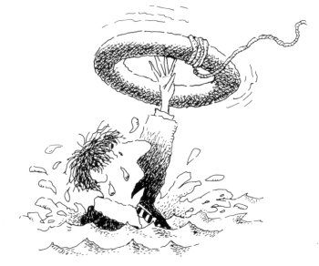
Let's take advantage of all the recent media publicity on the importance of libraries in difficult times.

With stimulus money coming into Vermont, we want to remind our legislators of the important role that public libraries play in economic recovery.

We will be handing out an information flyer to remind legislators about all that we do to partner with the government in helping Vermonters, and we'll also be giving out lifesaver candies to reinforce our point!

Here's all you have to do:
- Contact your legislators to ask for a brief appointment on April 15th to speak to them about what libraries are doing to help Vermonters. Also, take time to invite your legislators to the evening reception at the Vermont Library Conference on May 12th.
- Bring a trustee or friend of the library to reinforce your case.

For more information contact:
Vermont Library Association Government Relations Committee
Co chairs: Hilari Farrington, Kellogg-Hubbard Library 223-3338
Lisa von Kann, St. Johnsbury Athenaeum 748-8291

