Explore Vermont Libraries

with the Passport to Vermont Libraries

Win prizes!

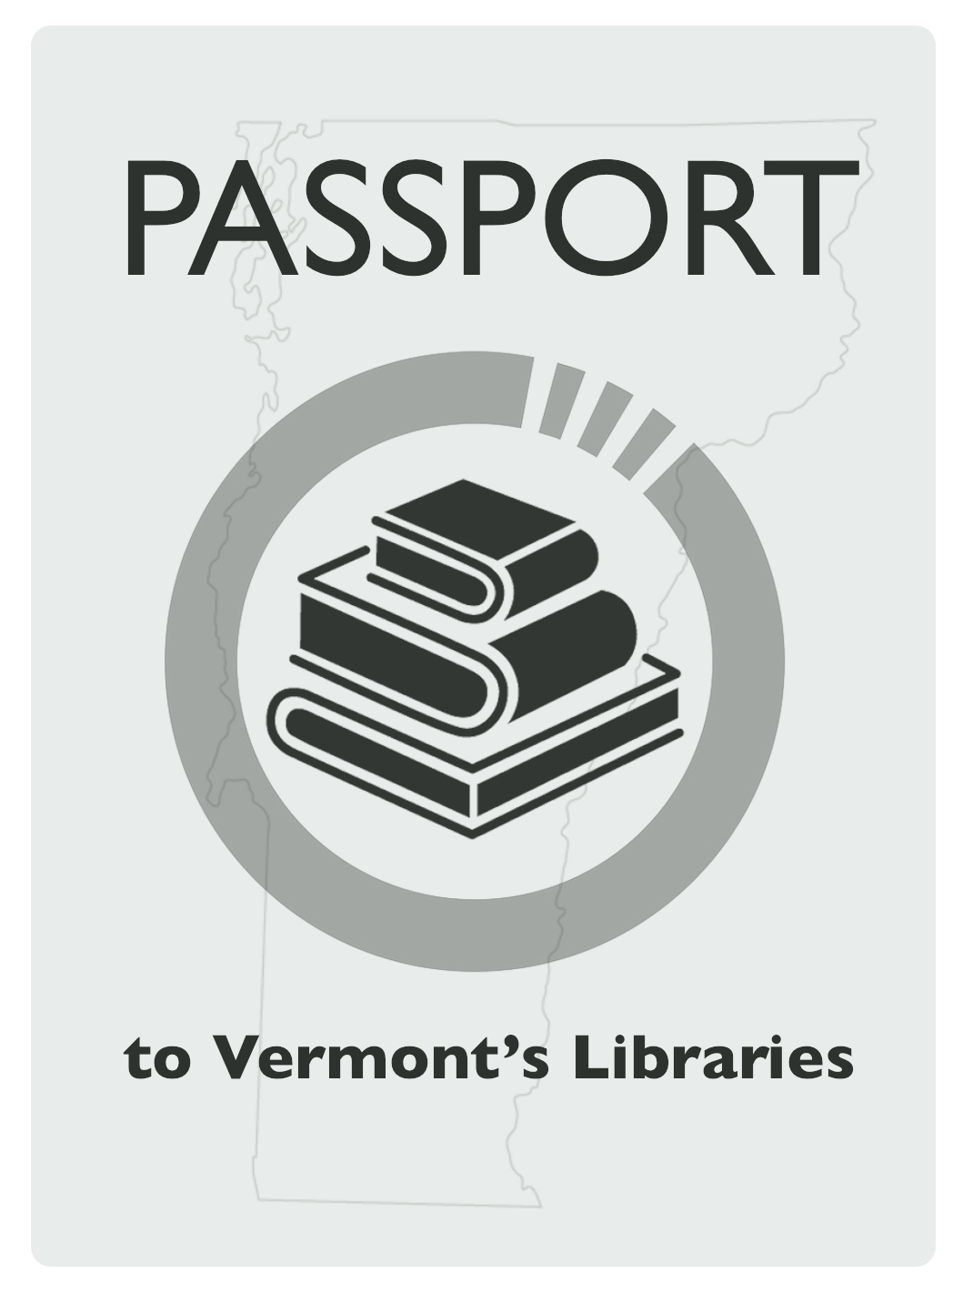

*How many libraries can you visit between   
June 1 – September 1, 2016?*

Get your Passport to Vermont Libraries at a participating library and explore. Sponsored by the Vermont Library Association.